**Airbnb Data Analysis**

**Low Level Design**



**Project On:**

**Title : Airbnb Data Analysis**

**By: Rushikesh Khandare**

1

**Contents:**

1. **Introduction…………………………………………………………………………………………03** 
   1. **What is Low-Level Design Document? …………………………………….03**
   2. **Scope ………………………………………………………………………….03**
2. **Architecture …………………………………………………………………………………….…..04**
3. **Power BI Architecture Description………..…………………………………………………...….06** 
   1. **Architecture Description …………………….…….………………………...06**
   2. **Export data from Python……………..……………………………………...07**
   3. **Data Preparation …………………………………………………………….08**

**4 Deployment …………………………………………………………………………………………12**

2

1. **Introduction** 
   1. **What is Low-Level design document?**

The goal of the LDD or Low-level design document (LLDD) is to give the internal logic design of the actual program code for the Expenditure Data Analysis dashboard. LDD describes the class diagrams with the methods and relations between classes and programs specs. It describes the modules so that the programmer can directly code the program from the document.

* 1. **Scope**

Low-level design (LLD) is a component-level design process that follows a step-by step refinement process. The process can be used for designing data structures, required software architecture, source code and ultimately, performance algorithms. Overall, the data organization may be defined during requirement analysis and then refined during data design work.

3

**2. Architecture**

## Power BI Desktop Architecture

1. **Get Power BI Desktop**

With Power BI Desktop, you can build advanced queries, models, and reports that visualize data. You can also build data models, create reports, and share your work by publishing to the Power BI service. Power BI Desktop is a free download.

1. **BI solution architecture in the Centre of Excellence**

BI solution architecture can consist of:

* + Data sources
  + Data ingestion
  + Big data / data preparation
  + Data warehouse
  + BI semantic models
  + Reports

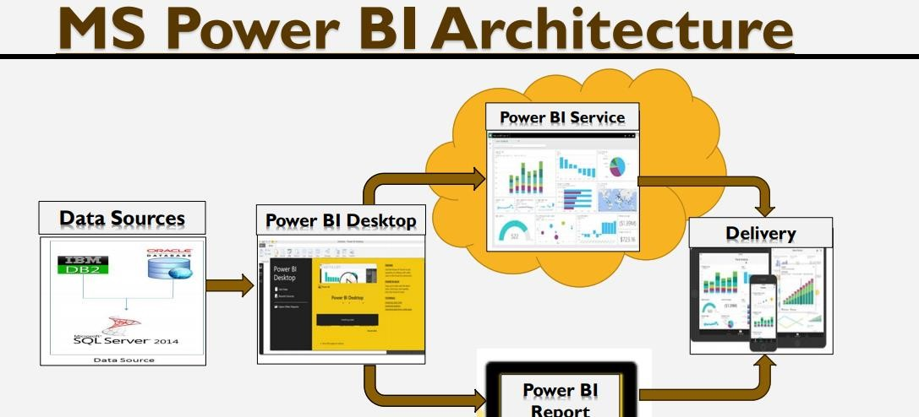

Fig: Power BI Architecture diagram

4

**Microsoft Power BI Desktop is a companion desktop application to Power BI.** With Power BI Desktop, you can:

1. **Get data:**

The Power BI Desktop makes discovering data easy. You can import data from a wide variety of data sources. After you connect to a data source, you can shape the data to match your analysis and reporting needs.

1. **Create relationships and enrich your data model with new measures and data formats:**

When you import two or more tables, oftentimes you'll need to create relationships between those tables. The Power BI Desktop includes the Manage Relationships dialog and the Relationships view, where you can use Autodetect to let the Power BI Desktop find and create any relationships, or you can create them yourself. You can also very easily create your own measures and calculations or customize data formats and categories to enrich your data for additional insights.

1. **Create reports:**

The Power BI Desktop includes the Report View. Select the fields you want, add filters, choose from dozens of visualizations, format your reports with custom colours, gradients and several other options. The Report View gives you the same great report and visualizations tools just like when creating a report on PowerBI.com.

1. **Save your reports:**

With the Power BI Desktop, you can save your work as a Power BI Desktop file. Power BI Desktop files have a .pbix extension.

1. **Upload or Publish your reports:**

You can upload the reports you created and saved in the Desktop to your Power BI site. You can also publish them to Power BI right from Power BI Desktop.

5

## 3. Architecture Description

**3.1. Data Description:** The Dataset contains month wise distribution San Diego, California for 2019 for the following columns:

1. **host_id**
2. **room_type:**

Entire home/apt

Private room

Shared room

1. **neighborhood**
2. **reviews**
3. **overall_satisfaction:**

5.0

0.0

4.5

4.0

3.5

3.0

1.5

2.5

1.0

1. **accommodates**

.

1. **bedrooms**:

1.0

2.0

3.0

0.0

4.0

5.0

6.0

10.0

7.0

8.0

9.0

1. **price**
2. **name**

6

1. **last_modified**
2. **latitude**
3. **longitude**
4. **location**

**3.2 Export Data from Python**

3.6**Perform Exploratory Data Analysis Using Python:**

1. **Import Python Modules**
2. **Load Dataset**
3. **Data Preparation**
4. **EDA: Data Visualization**

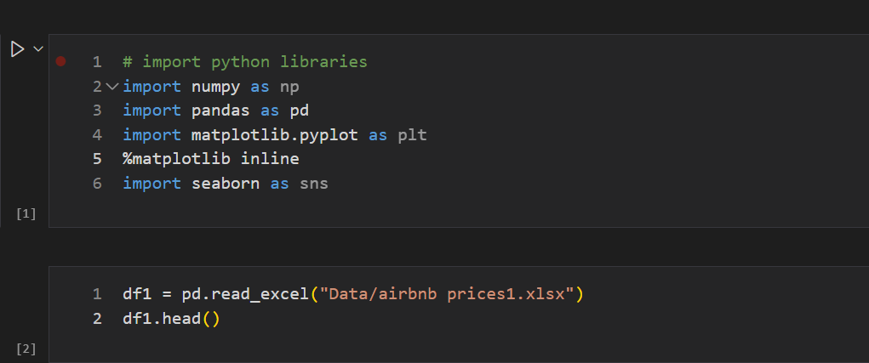

* After performing Pre-processing and cleaning dataset.
* After cleaned data, its exported into csv as a Final Airbnb Prices.csv.
* Now this cleaned dataset uses for creating dashboard in Power BI.

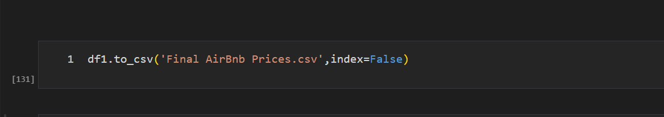

7

**3.3 Data Preparation:**

* In the Preparation Process, we will convert our original datasets with other necessary attributes format.
* All the datasets is of same format as shown below: Original dataset.

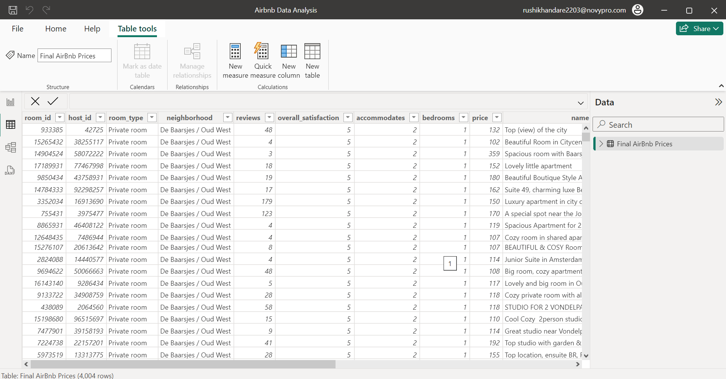

* As you all can notice that format of the data, we have is not good to analyse and visualize. So, we need to reconstruct the structure of the dataset.

8

### **We will be using only Power BI with power query for data restructuring and cleaning purpose.**

* Also We can upload csv data from Home section, click on Data tab, click on get data ,then from text or csv and upload dataset into Power query editor.
* Power Query Editor window will get popped up.

**Step 1) Home Section:**

* Click on Remove Rows at Reduce Rows Section.

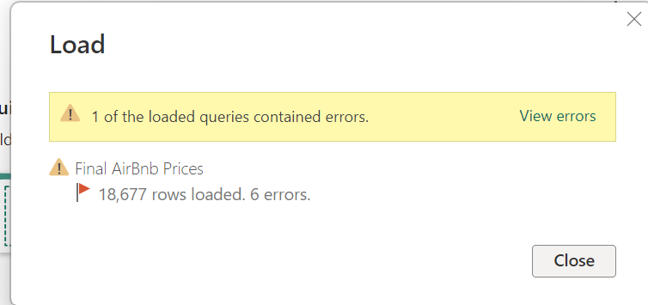

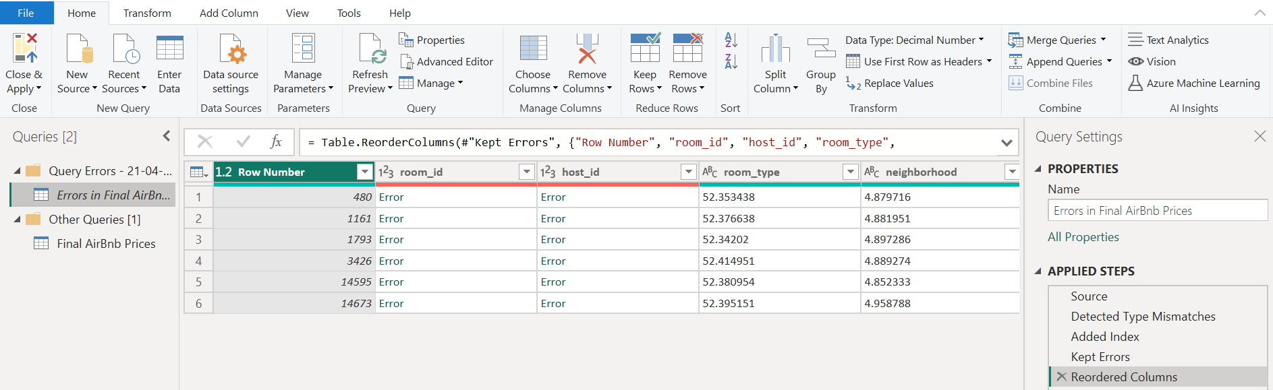

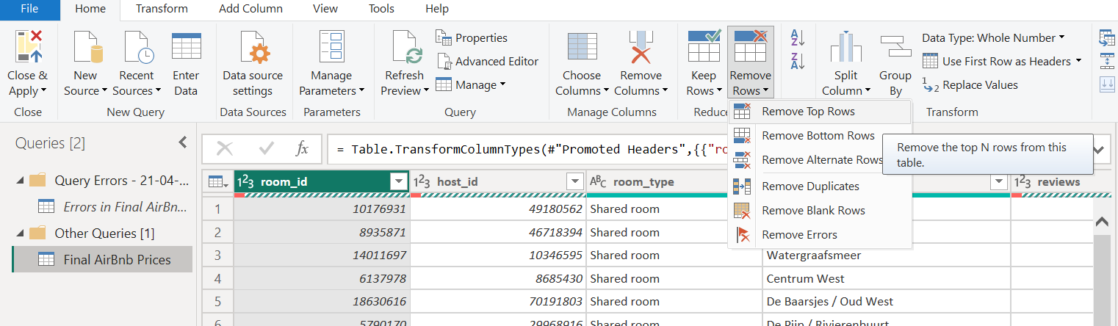

9

* Remove Unnecessary rows.

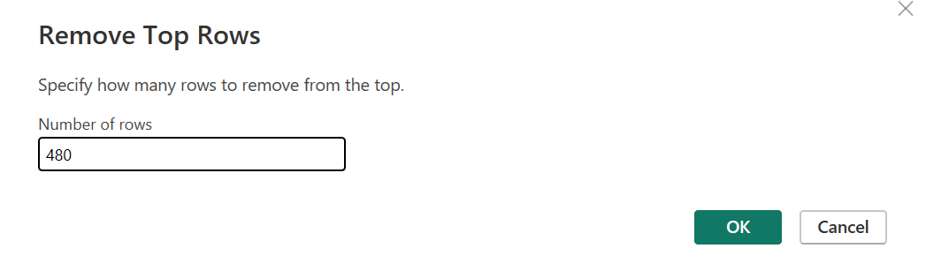

* Delete Error Group

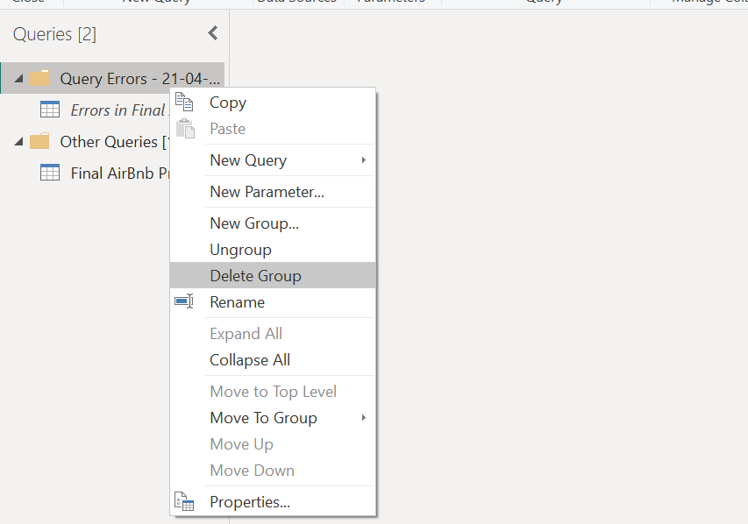

10

**Step 3) Close and save:**

* Now go to Home section and click close and load.
* In such a way we preparing dataset and now we need to all these steps for all the others datasets we have.
* And save it into new folder as prepared data.

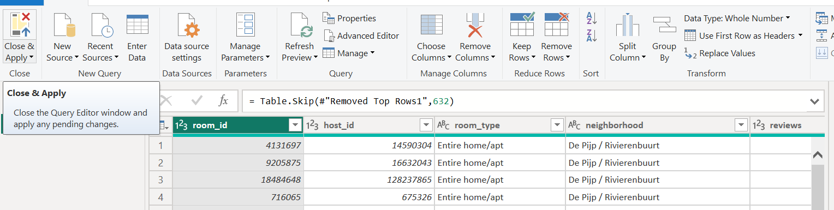

10

11

## 4. Deployment

**For Development I used Power BI and NovyPro**

Once you’ve completed your dashboard, follow these steps:

1. Load dataset on Power BIin csv formats and creates visuals for dashboard.
2. After creating all visual, create insightful dashboard.
3. Then Login into Power BI Service by using Microsoft developer account.
4. Then create new project workspace for uploading dashboard and reports into this workspace.
5. Then login into NovyPro Power BI account.

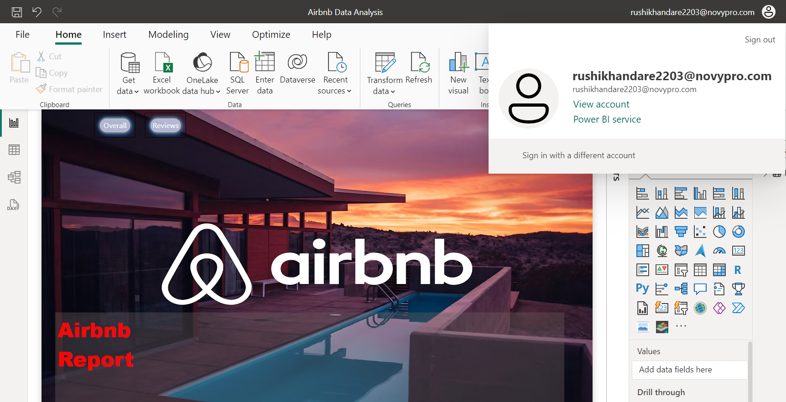

88

1. 6. Then share dashboard as embedded link as a web into NovyPro portfolio.